**Experiment No :** 14

**Experiment name :** Write a C program to compute the value of Euler’s number that is used as the base of natural logarithms . Using the following formula e = 1+1/1!+1/2!+1/3!+…….+1/n!

**Methodology :**

This program calculates the value of Euler's number (e) using the given formula up to the given value of n. It uses a loop to calculate the factorial and sum up the terms in the series. The computeEulerNumber function returns the value of e. The user is prompted to enter the value of n, and the result is displayed.

**Flow-Chart :**

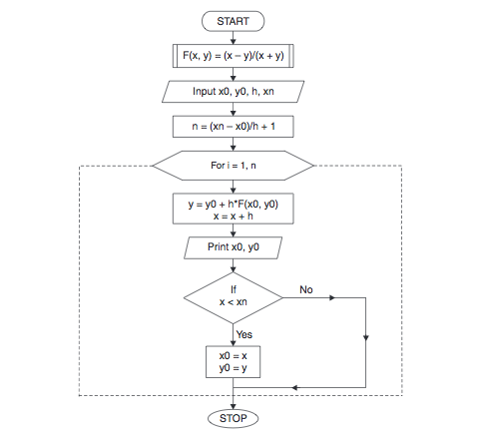

**Code :**

#include<stdio.h>

int main (void)

{

int n,i,j;

float e=1.0, nFact=1;

printf("please enter the number: ");

scanf("%d", &n);

for( i =1; i<= n ; i++)

{

nFact*=i;

e = e + (1.0/ nFact);

}

printf("The value of 'e' is : %f", e);

return 0;

}

**Output:**

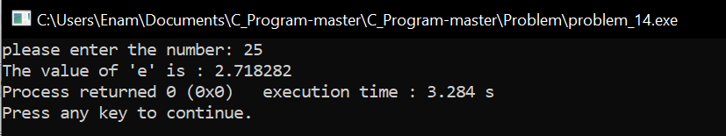

**Result discussion :**

1. Input the value of 'n' from the user (the number of terms).
2. Initialize 'e' to 1.0 (since the series starts with 1).
3. Use a loop to calculate the factorial of each 'i' from 1 to 'n'.
4. Calculate the term for each 'i' as 1 / factorial(i).
5. Add the term to the current value of 'e'.
6. Repeat steps 3 to 5 for all 'i' from 1 to 'n'.
7. Output the computed value of 'e' as the result.